Weekly Activity 4:
Introduction to Acoustics

This activity is an individual activity. You will not work in groups.

This activity requires that you describe the time and space variation of a pressure wave mathematically as well as work with sinusoidal motion. As you now know, sound travels through air as a pressure wave. Individual air molecules do not travel from a sound source to the listeners’ ears (otherwise, the air molecules from a speaker’s lungs would enter your ear!). Instead, the incident wave (original disturbance, in our case the vibration of the vocal folds and the shaping of that sound in the vocal tract through articulation) is propagated through the air as the air molecules move back and forth around a state of equilibrium. Eventually, the motion is moved from the source (incident) farther and farther through air. This is similar to a really crowded room where one person in the back pushes someone really hard. If that person bumps into others, a “wave” is propagated through the crowd. The original person who got pushed doesn’t move all the way to the front of the room… instead, that energy is spread throughout the bodies in the room. Similarly, when a pebble is thrown into water, the wave is propagated through the water from the source outward.




Since sound travels through air as a wave, it varies in terms of time and space.

Time (temporal) Variation
Frequency(f) refers to the rate at which something occurs. In speech acoustics, we usually are referring to how often a cycle of vibration is occurring. That vibration can be at the level of the vocal folds or at any articulatory constriction in the vocal tract (make the /s/ sound- that is a constriction without vocal fold vibration).

The period (T) is a measure of time variance that describes the length of time it takes for one, single vibratory cycle to occur (from rest to maximum displacement back through resting position to maximum displacement in the opposite direction and then back to resting position).

The period (T) of a vibration and the frequency of that vibration have a predictable relationship such that f = 1/T. That means that as the frequency increases (how many vibrations occur in one second which is measured in hertz or Hz), the period decreases. So, if f increases, the time it takes for one cycle to take place (T) decreases. If f decreases, T increases.

Space (spatial) Variation
If pressure waves are “alternating regions of high and low pressure extending across space,” we can measure how long one of these regions is. The basic unit of analysis for this measurement is one area of low molecule density (rarefaction) and one area of high molecule density (compression). Actually, this can also be measured as one area of compression and one area of rarefaction. It doesn’t matter which one you start with as long as you are consistent.

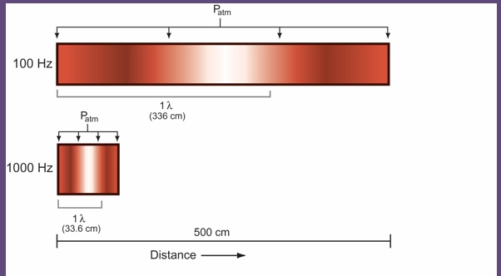

As you can see from the image above, the 100 Hz (100 vibrations per second) pressure wave propagates (individual molecules don’t move far from home… they stay close and move to and fro) from relatively light at the far left (low density), to dark toward the right, through atmospheric pressure (resting position) in the white center and then toward light (The first three downward pointing arrows from left to right).

The 1000Hz pressure wave is, however, different. The movement from less dense to more dense back to less dense takes up far less space. That is because there is a predictable relationship between frequency (f) and wavelength (λ) which is the distance it takes to move from “an alternating region of low to high pressure.”

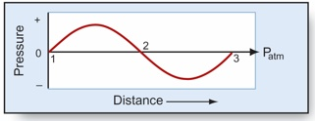

We can see that same relationship on the sine wave above. The wavelength (λ) can be visualized as being the distance from the number 1 above to the number 3. This was randomly chosen. We could also measure the wavelength from the crest on the top of the sine wave (above the horizontal line or x-axis) to the next crest on top of the x-axis. We could also decide to measure wavelength from the crest under the x-axis to the next crest under the x-axis of the next cycle but neither of those is shown in the picture. The point is that wavelength is the distance between successive crests of a wave. You can choose which “crest” to use to measure wavelength.

Like the period (T), wavelength (λ) has a relationship with frequency (f).
Such that: λ = c/f or f = c/ λ, where c is the speed of sound (33,600 cm/s).

That means frequency and wavelength have an inverse relationship. As frequency increases, wavelength decreases (and vice versa).

Sinusoidal Motion
Sinusoidal motion is the most basic type of acoustic event. Sinusoidal motion is derived from the linear projection of uniform circular speed. That only means that the path of an object traveling in a circle of a given circumference (width or height) is transferred to a straight line.

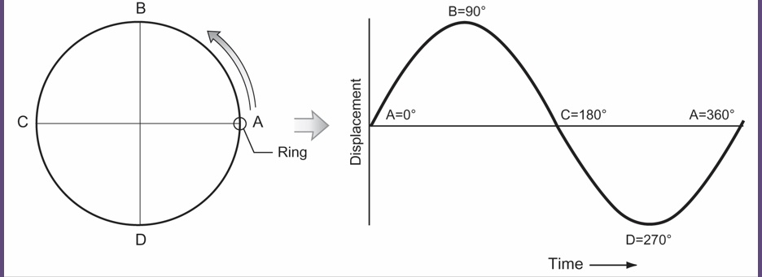

The reason this is important is that the sine wave we see to the right of the circle above is really just the motion of the “ring” traveling around the circle at a given speed. Because it is crossing angles, plotting it in a straight line will involve some trigonometry. The sinusoidal function will tell us what the sine wave looks like and is really a function of time (location of the “ring” at any given time). Therefore, the sinusoidal function is:
$D=A\sin{(2πft+ ∅}$)
where D = displacement of the object at the given time, A = maximum displacement of the object from the rest position, f = frequency of motion, t = specific time being computed and $∅$ = the starting phase of the motion (where on the circle did it start?). The reason sin (a trigonometric function) plays a role is because it helps handle the angles from the uniform circular speed basis of sinusoidal motion. The value of sin can be found in mathematical tables.

The displacement (D) can be thought of as the amplitude of the sine wave (how high it is). For instance, if an air molecule moves a long way from home before changing directions during a vibratory cycle, the molecule displacement will be greater than that of an air molecule that only moves a little ways from home. The height of a sine wave’s crests can be thought of as the displacement and is called amplitude. The phase of a sine wave is only the starting point. One might start inspecting a sine wave at the first “low” crest below the x-axis (270 degrees above) or at the crossing point of the x-axis (either 0 or 180 degrees in the above image). It all depends on what one wants to do. As long as the phase is known, it doesn’t matter where you start plotting your sinusoidal motion.

Assignment
Complete the following problems and fill your answers in below. Only submit the portion of the assignment from here on (you can erase what is above for submission). You will need a word processing and spreadsheet software package to complete it. Upload to Blackboard in the weekly activity section. Don’t forget to include your name!!

1. Compute the periods for each of the frequencies listed on the x-axis of the graph below, record them and plot them, connecting the plotted points with a continuous curve. Round to the nearest whole number (your values should match the ones on the y-axis). I have provided the scale values for the x-axis but you will provide the label for the y-axis (what is the unit of measure for the y-axis?). Here is an example of how to do a similar problem: https://youtu.be/ClOLcwWx9aQ. If you want to create your own graph in excel, be sure to show labels for the axes so I know you know the values (and then copy and paste that graph in this document, replacing the graph below). Otherwise, you can print this one page and graph it by hand (and fill in the unit of measurement for the y-axis) and take a picture of it. Use that picture to replace the graph below.

T-values when f is:

150Hz_____ 400Hz____ 1050Hz___ 1350Hz____ 2500Hz____ 3000Hz____

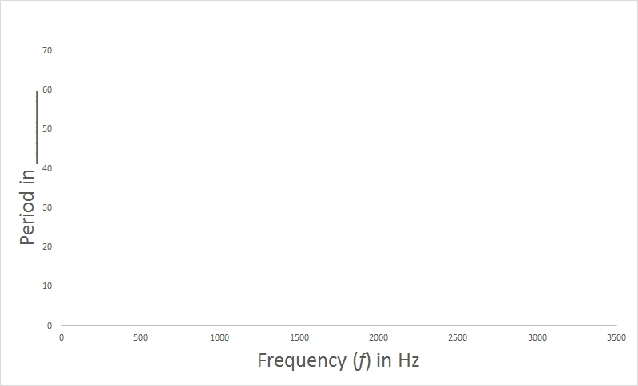

2. Based on your line graph, what can you say about the relationship between frequency (f) and period (T)?

3. Compute the wavelength for each of the frequencies listed below. Then, record them and plot them in Excel (or whatever you use as a spreadsheet software), connecting the plotted points with a continuous curve. Round to the nearest whole number. Be careful with your measurement values (be consistent!). Label both axes (with words). If you are not sure how, an internet search will help you figure out how to label graph axes in your software package. Look at the empty graph above for some help.

Wavelength when f is:

150Hz_____ 400Hz____ 1050Hz___ 1350Hz____ 2500Hz____ 3000Hz____

Paste your graph below.

4. We have the sinusoidal function $D=A\sin{(2πft+ ∅}$) that will tell us the displacement of an object at any given moment in time. But, if we are not interested in the absolute starting phase of the waveform, we can simply to $D=A \left(sin∅\right)$, where $∅$ is the angle formed between reference radii. What was left out in the new formula and why do you think we can simplify this way?

5. Using the simplified sinusoidal motion formula, $D=A \left(sin∅\right)$, and the table of sines below, plot the amplitudes as a function of time (time of observation below) for the following data, where A = 20. Use spreadsheet software to create your plot and label the plot completely. Here is a short tutorial: https://youtu.be/g31f52E2tR0. Fill in the Amplitude column below and copy and paste your plot below the table.

Plot these data |  |  | Sine Table
Time | Angle | Amplitude | 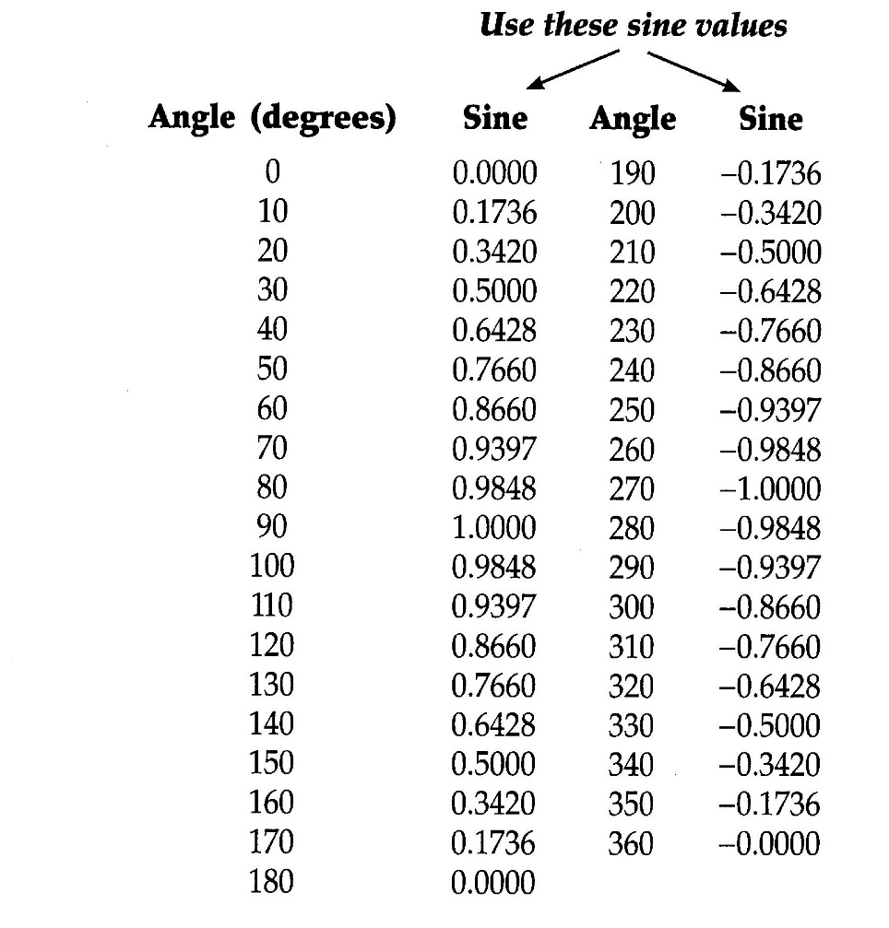
0 | 0
1 | 30
2 | 80
3 | 110
4 | 160
5 | 180
6 | 220
7 | 260
8 | 300
9 | 340
10 | 0

